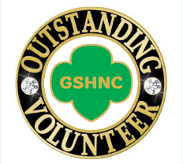
Girl Scouts, Hornets’ Nest Council
7007 Idlewild Road, Charlotte, NC 28212
704-731-6500, Website: www.hngirlscouts.org

Outstanding Volunteer Nomination
The Outstanding Volunteer Pin recognizes active, registered Girl Scout adult volunteers who have provided outstanding service for 2 or more years.

Process Please complete this nomination form (or a letter with all of the required information) and submit it to your Service Unit Awards Coordinator by March 15 for consideration for this award. The Service Unit Awards Committee will review all nominations and determine who will receive the awards.

Criteria The candidate has consistently performed at a level that exceeds expectations for at least 2 years. This award requires a nomination plus one person who supports the nomination.

Nominee Name Position/Role

Email Troop & Service Unit

How do you know the nominee?

Please give a detailed description, including at least 2 examples, of how the nominee has provided outstanding service to Girl Scouts (use reverse side if more room is needed)

1. Name of Person Submitting this Nomination

Name Position/Role

Email Troop & Service Unit

Signature Date

2. Name of Person Supporting this Nomination

Name Position/Role

Email Troop & Service Unit

Signature of Support Date

